
Trinity Episcopal Church

Invite. Include. Inspire.

The Fourth Sunday
after the Epiphany

Holy Eucharist Rite II
February 1, 2026

trinitychurch@trinitytroyohio.org
www.trinitytroyohio.org

Welcome to Trinity Episcopal Church

We are delighted to have you with us today.
Everything that you need for the liturgy can be found in this bulletin.
If you have questions, please don’t hesitate to ask someone around you.
Children are always welcome in the church.

Copyright information:
Kyrie, Sanctus, and Fraction Anthem from New Plainsong by David Hurd ©1981 G.I.A Publications
H590: Words by Bradford Gray Webster ©1954 by the Hymn Society of America, Music by David Evans, Oxford University Press. H347 Words by Mildred E Peacey Music ©1985 by Hope Publishing Co. All other copyright listed under the music or are part of the Public Domain. Reprinted with permission under One License #A-700000. All Rights reserved.

The Word of God

Prelude: Saraband from Sonata No. 8, Op. 5 - Corelli Christina Roberts, Flute
Please stand as you are able for the procession.

Processional Hymn: Tell out, my soul, the greatness of the Lord! H437
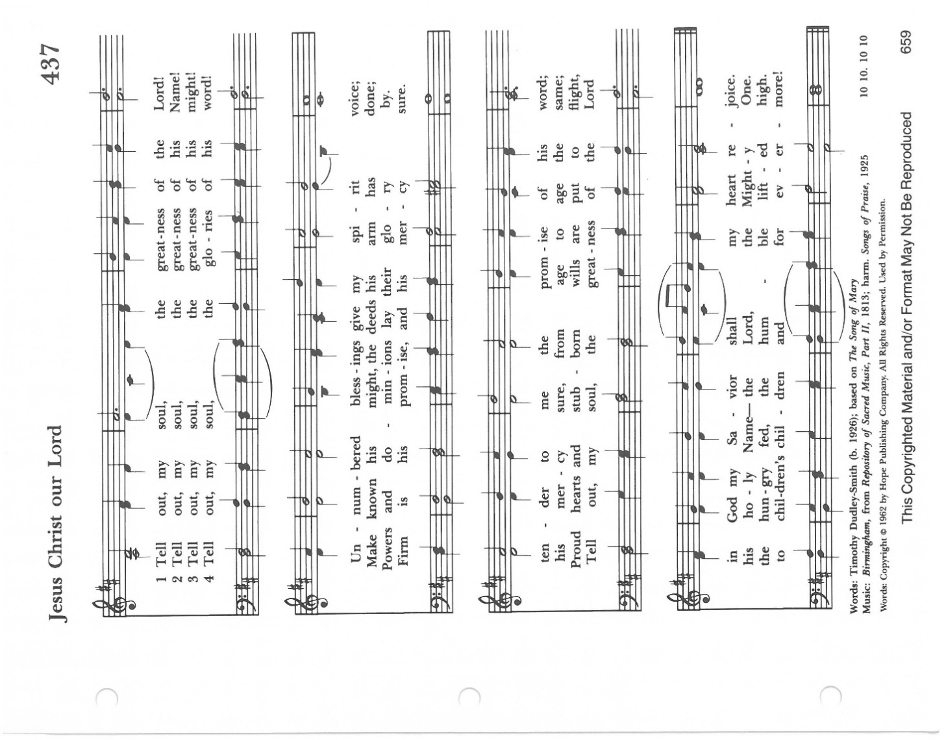
The Opening Acclamation:

Celebrant: Blessed be our God.
People: And blessed be God’s kingdom, now and forever. Amen

Collect for Purity:

Celebrant: Almighty God, to you all hearts are open, all desires known, and from you no secrets are hid: Cleanse the thoughts of our hearts by the inspiration of your Holy Spirit, that we may perfectly love you, and worthily magnify your holy Name; through Christ our Lord. Amen.

Gloria S280
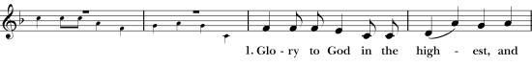
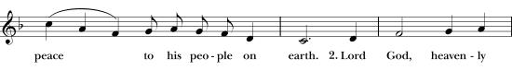
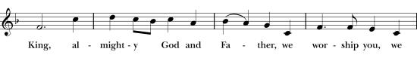
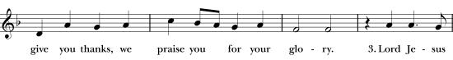
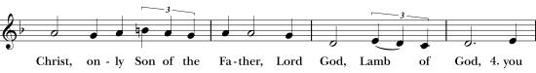
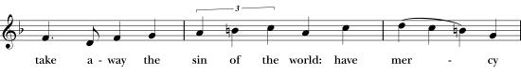
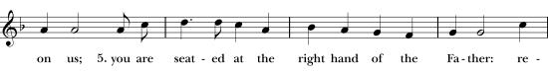
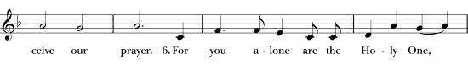
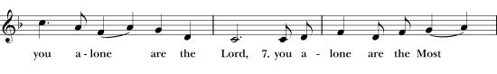
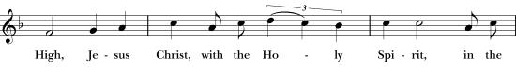
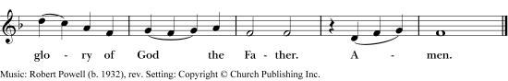
The Collect of the Day:

Celebrant: The Lord be with you.
People: And also with you.
Celebrant: Let us pray.

Almighty and everlasting God, you govern all things both in heaven and on earth: Mercifully hear the supplications of your people, and in our time grant us your peace; through Jesus Christ our Lord, who lives and reigns with you and the Holy Spirit, one God, for ever and ever. Amen.
Please be seated for the reading of scripture.

The First Lesson: Micah 6:1-8
Lector: A reading from the book of Micah

Hear what the Lord says:
Rise, plead your case before the mountains,
and let the hills hear your voice.
Hear, you mountains, the controversy of the Lord,
and you enduring foundations of the earth;
for the Lord has a controversy with his people,
and he will contend with Israel.

“O my people, what have I done to you?
In what have I wearied you? Answer me!
For I brought you up from the land of Egypt,
and redeemed you from the house of slavery;
and I sent before you Moses,
Aaron, and Miriam.
O my people, remember now what King Balak of Moab devised,
what Balaam son of Beor answered him,
and what happened from Shittim to Gilgal,
that you may know the saving acts of the Lord.”

“With what shall I come before the Lord,
and bow myself before God on high?
Shall I come before him with burnt-offerings,
with calves a year old?
Will the Lord be pleased with thousands of rams,
with tens of thousands of rivers of oil?
Shall I give my firstborn for my transgression,
the fruit of my body for the sin of my soul?”
He has told you, O mortal, what is good;
and what does the Lord require of you
butt to do justice, and to love kindness,
and to walk humbly with your God?

Lector: Hear what the Spirit is saying to God’s people.
People: Thanks be to God.

The Psalm: Psalm 15

Domine, quis habitabit?

1 Lord, who may dwell in your tabernacle? *
who may abide upon your holy hill?
2 Whoever leads a blameless life and does what is right, *
who speaks the truth from his heart.
3 There is no guile upon his tongue;
he does no evil to his friend; *
he does not heap contempt upon his neighbor.
4 In his sight the wicked is rejected, *
but he honors those who fear the Lord.
5 He has sworn to do no wrong *
and does not take back his word.
6 He does not give his money in hope of gain, *
nor does he take a bribe against the innocent.
7 Whoever does these things *
shall never be overthrown.

The Second Lesson: 1 Corinthian 1:18-31

Lector: A reading from the book of Corinthians

The message about the cross is foolishness to those who are perishing, but to us who are being saved it is the power of God. For it is written,

“I will destroy the wisdom of the wise,
and the discernment of the discerning I will thwart.”

Where is the one who is wise? Where is the scribe? Where is the debater of this age? Has not God made foolish the wisdom of the world? For since, in the wisdom of God, the world did not know God through wisdom, God decided, through the foolishness of our proclamation, to save those who believe. For Jews demand signs and Greeks desire wisdom, but we proclaim Christ crucified, a stumbling block to Jews and foolishness to Gentiles, but to those who are the called, both Jews and Greeks, Christ the power of God and the wisdom of God. For God's foolishness is wiser than human wisdom, and God's weakness is stronger than human strength.

Consider your own call, brothers and sisters: not many of you were wise by human standards, not many were powerful, not many were of noble birth. But God chose what is foolish in the world to shame the wise; God chose what is weak in the world to shame the strong; God chose what is low and despised in the world, things that are not, to reduce to nothing things that are, so that no one might boast in the presence of God. He is the source of your life in Christ Jesus, who became for us wisdom from God, and righteousness and sanctification and redemption, in order that, as it is written, “Let the one who boasts, boast in the Lord.”

Lector: Hear what the Spirit is saying to God’s people.
People: Thanks be to God.

Please stand as you are able.

Gradual Hymn: Blest are the pure in heart H-656

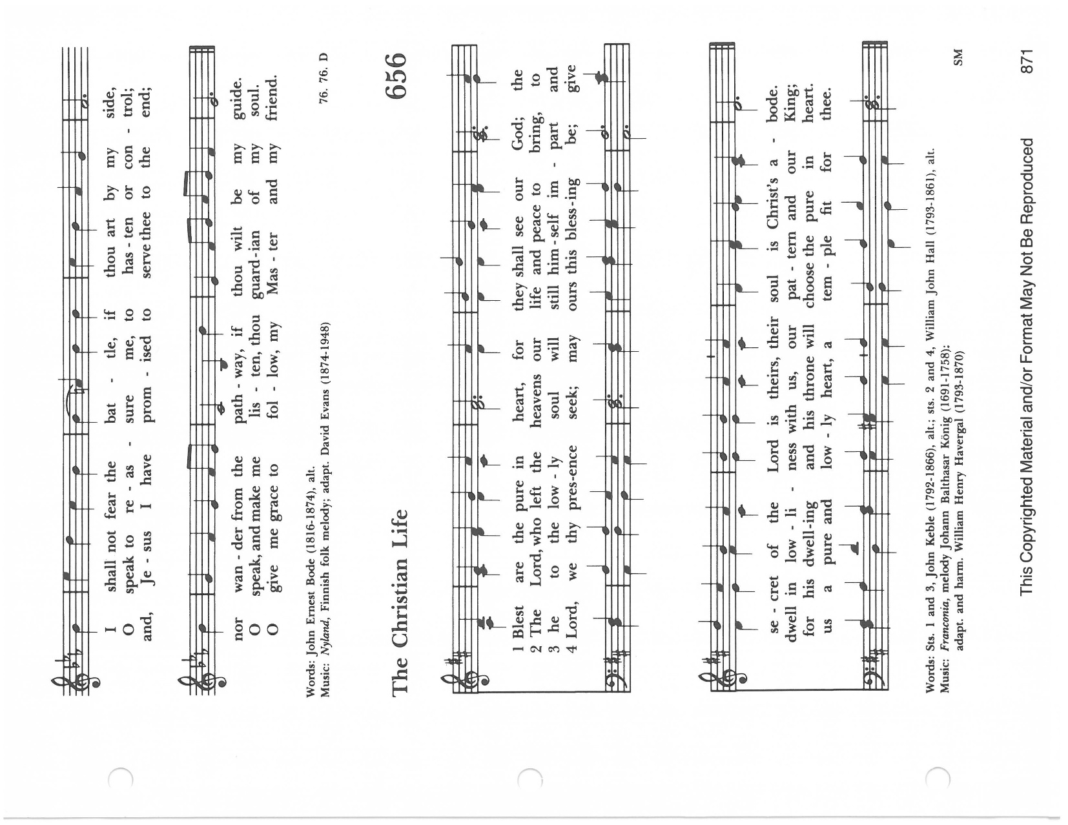

The Gospel: Matthew 5:1-12
Celebrant: The Holy Gospel of our Lord Jesus Christ according to Matthew
People: Glory to you, Lord Christ.

When Jesus saw the crowds, he went up the mountain; and after he sat down, his disciples came to him. Then he began to speak, and taught them, saying:

“Blessed are the poor in spirit, for theirs is the kingdom of heaven.
“Blessed are those who mourn, for they will be comforted.
“Blessed are the meek, for they will inherit the earth.
“Blessed are those who hunger and thirst for righteousness, for they will be filled.
“Blessed are the merciful, for they will receive mercy.
“Blessed are the pure in heart, for they will see God.
“Blessed are the peacemakers, for they will be called children of God.
“Blessed are those who are persecuted for righteousness’ sake, for theirs is the
kingdom of heaven.
“Blessed are you when people revile you and persecute you and utter all kinds of
evil against you falsely on my account. Rejoice and be glad, for your reward is
great in heaven, for in the same way they persecuted the prophets who were
before you."

Celebrant: The Gospel of the Lord
People: Praise to you, Lord Christ.

Please be seated.

Children’s Sermon: All children are welcome to the front of the church for a gathering with Reverand Slane.

Sermon Rev. Melanie Slane

Please stand as you are able.

The Nicene Creed

Celebrant: Let us confess our faith in the words of the Nicene Creed.

Celebrant and People:

We believe in one God,
the Father, the almighty,
maker of heaven and earth
of all that is, seen and unseen.

We believe in one Lord, Jesus Christ,
the only Son of God,
eternally begotten of the Father,
God from God, Light from Light,
true God from true God,
begotten, not made,
of one Being with the Father.
Through him all things were made.
For us and for our salvation
he came down from heaven:
by the power of the Holy Spirit
he became incarnate from the Virgin Mary,
and was made man.
For our sake he was crucified under Pontius Pilate;
he suffered death and was buried.
On the third day he rose again
in accordance with the Scriptures;
he ascended into heaven
and is seated at the right hand of the Father.
He will come again in glory to judge the living and the dead,
and his kingdom will have no end.

We believe in the Holy Spirit, the Lord, the giver of life,
who proceeds from the Father and the Son.
With the Father and the Son he is worshiped and glorified.
He has spoken through the Prophets.
We believe in one holy catholic and apostolic Church.
We acknowledge one baptism for the forgiveness of sins.
We look for the resurrection of the dead,
and the life of the world to come. Amen.

The Prayers of the People:

Lector: God of revelation, as we gather in praise for the gracious mystery of your Son, we remember the many needs of your church and your world.

For the Church: that we may be given wisdom and discernment: that we might become a leading star for others in their journey to Christ.
Arise, shine; for your light has come,

People: and the glory of the Lord has risen upon you.

Lector: For this nation and all in authority around the world: grant us
knowledge and sound judgement, so that we might help bring justice
peace, and mercy to all people.
Arise, shine; for your light has come

People: and the glory of the Lord has risen upon you.

Lector: For the earth and or for the wisdom and ability to conserve it: that we might see how you are made manifest through all creation.
Arise, shine; for your light has come

People: and the glory of the Lord has risen upon you.

Lector: For all who suffer in body, mind, or spirit, especially for Becky Daffner, Bill Shaw, Jo Stull, Leanne Jones and all those on our prayer list. We pray that your healing light be with them. Arise, shine; for your light has come

People: and the glory of the Lord has risen upon you.

Lector: For all those who have died: that they might know the light of your resurrection. Arise, shine; for your light has come.

People: and the glory of the Lord has risen upon you.

Celebrant: Blessed are you, O Lord out Gord, who so loved the world that you gave s your only Son. Hear the prayers we offer this day and lead us into your kingdom; through Jesus Christ our Lord. Amen.

Confession of Sin

Celebrant: Let us humbly confess our sins unto Almighty God

People: Most merciful God, we confess that we have sinned against you
in thought, word, and deed,
by what we have done,
and by what we have left undone.
We have not loved you with our whole heart;
we have not loved our neighbors as ourselves.
We are truly sorry and we humbly repent.
for the sake of your Son Jesus Christ,
have mercy on us and forgive us;
that we may delight in thy will,
and walk in your ways,
to the glory of your Name. Amen.

Celebrant: Almighty God have mercy on you, forgive you all your sins through our Lord Jesus Christ, strengthen you in all goodness and by the power of the Holy Spirit keep you in eternal life. Amen

Celebrant: The peace of the Lord be always with you.
People: And also with you.

You are welcome to share the sign of the peace with the people around you.

Announcements

The Holy Communion

Offertory Sentence: Let us with gladness present the offerings and oblations of our life and labor to the Lord.

Offertory Hymn: LEVAS II #38 On a hill far away

Please stand as you are able.

Presentation Hymn: Praise God from whom all blessings flow H-380 vs 3

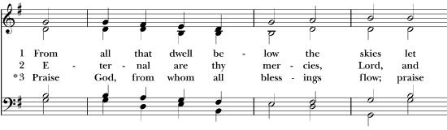
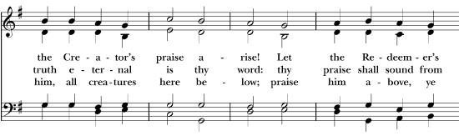
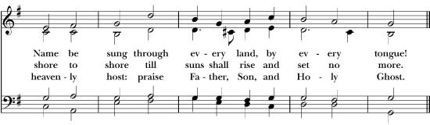

The Great Thanksgiving: Eucharistic Prayer B

Celebrant: The Lord be with you.
People: And also with you.
Celebrant: Lift up your hearts.
People: We lift them to the Lord.
Celebrant: Let us give thanks to the Lord our God
People: It is right to give our thanks and praise.

Celebrant: It is right, and a good and joyful thing, always and everywhere to give thanks to you, Father Almighty, Creator of heaven and earth. Therefore we praise you, joining our voices with Angels and Archangels and with all the company of heaven, who for ever sing this hymn to proclaim the glory of your Name:

Sanctus: Holy, holy, holy S129

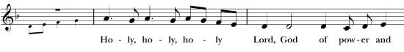
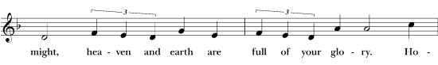
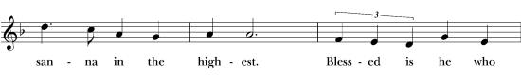
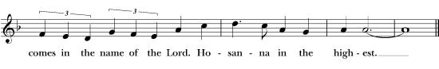

The Celebrant continues:

We give thanks to you, O God, for the goodness and love which you have made known to us in creation; in the calling of Israel to be your people; in your Word spoken through the prophets; and above all in the Word made flesh, Jesus, your Son. For in these last days you sent him to be incarnate from the Virgin Mary, to be the Savior and Redeemer of the world. In him, you have delivered us from evil, and made us worthy to stand before you. In him, you have brought us out of error into truth, out of sin into righteousness, out of death into life.:

On the night before he died for us, our Lord Jesus Christ took bread; and when he had given thanks to you, he broke it, and gave it to his disciples, and said, “Take, eat: This is my Body, which is given for you. Do this for the remembrance of me.”

After supper he took the cup of wine; and when he had given thanks, he gave it to them, and said, “Drink this, all of you: This is my Blood of the new Covenant, which is shed for you and for many for the forgiveness of sins. Whenever you drink it, do this for the remembrance of me.”

Therefore, according to his command, O Father,

Celebrant and People: We remember his death,
We proclaim his resurrection,
We await his coming in glory!

And we offer our sacrifice of praise and thanksgiving to you, O Lord of all; presenting to you, from your creation, this bread and this wine.

We pray you, gracious God, to send your Holy Spirit upon these gifts that they may be the Sacrament of the Body of Christ and his Blood of the new Covenant. Unite us to your Son in his sacrifice, that we may be acceptable through him, being sanctified by the Holy Spirit.

In the fullness of time, put all things in subjection under your Christ, and bring us to that heavenly country where we may enter the everlasting heritage of your sons and daughters; through Jesus Christ our Lord, the firstborn of all creation, the head of the Church, and the author of our salvation.
By him, and with him, and in him, in the unity of the Holy Spirit all honor and glory is yours, Almighty Father, now and for ever. AMEN.

And now, as our Savior Christ has taught us, we now pray,

Celebrant and People: Our Father, who art in heaven,
hallowed be thy Name,
thy kingdom come,
thy will be done,
on earth as it is in heaven.
Give us this day our daily bread.
And forgive us our trespasses,
as we forgive those
who trespass against us.
And lead us not into temptation,
but deliver us from evil.
For thine is the kingdom,
and the power, and the glory,
for ever and ever. Amen

The Breaking of the Bread

Fraction Anthem: Christ Our Passover S-154

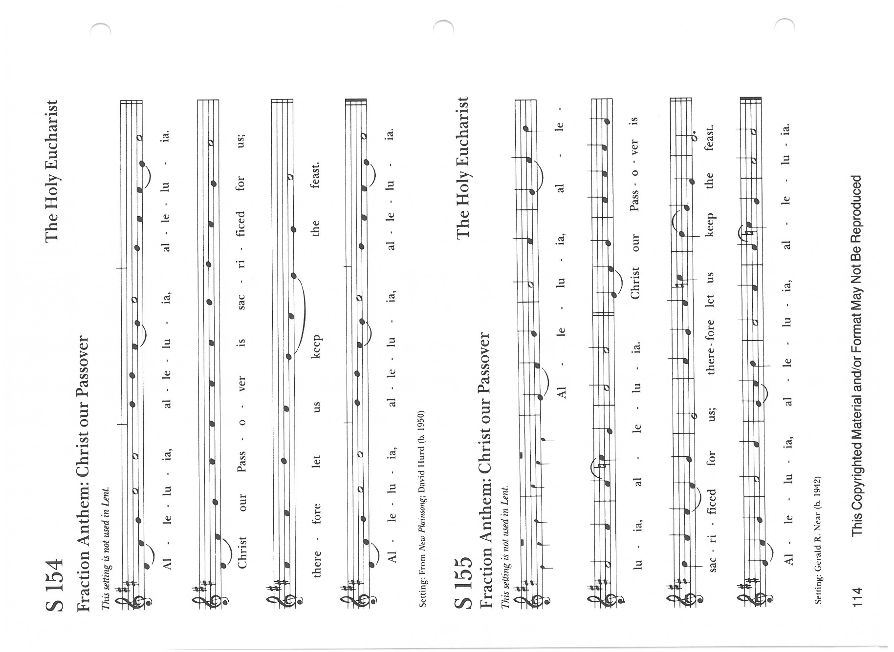

Celebrant: This is the table, not of the church, but of the Lord. It is made ready
for those who love God and for those who want to love God more.
So come you who have much faith. And you who have little; You
who have been here often and you who have not been here long;
You who have tried to follow and you who have failed. Come
because it is the Lord who invites you.

The Gifts of God for the People of God.

You are welcome to join us at communion. Please come forward to the rail when indicated by an usher. You may drink from the common cup, or intinct (dip) the bread in the second cup.
Cross your arms over your chest if you prefer a blessing.
Please let the presider know if you need a gluten free wafer.

Music During Communion:

Forgive Our Sins as we Forgive H-674
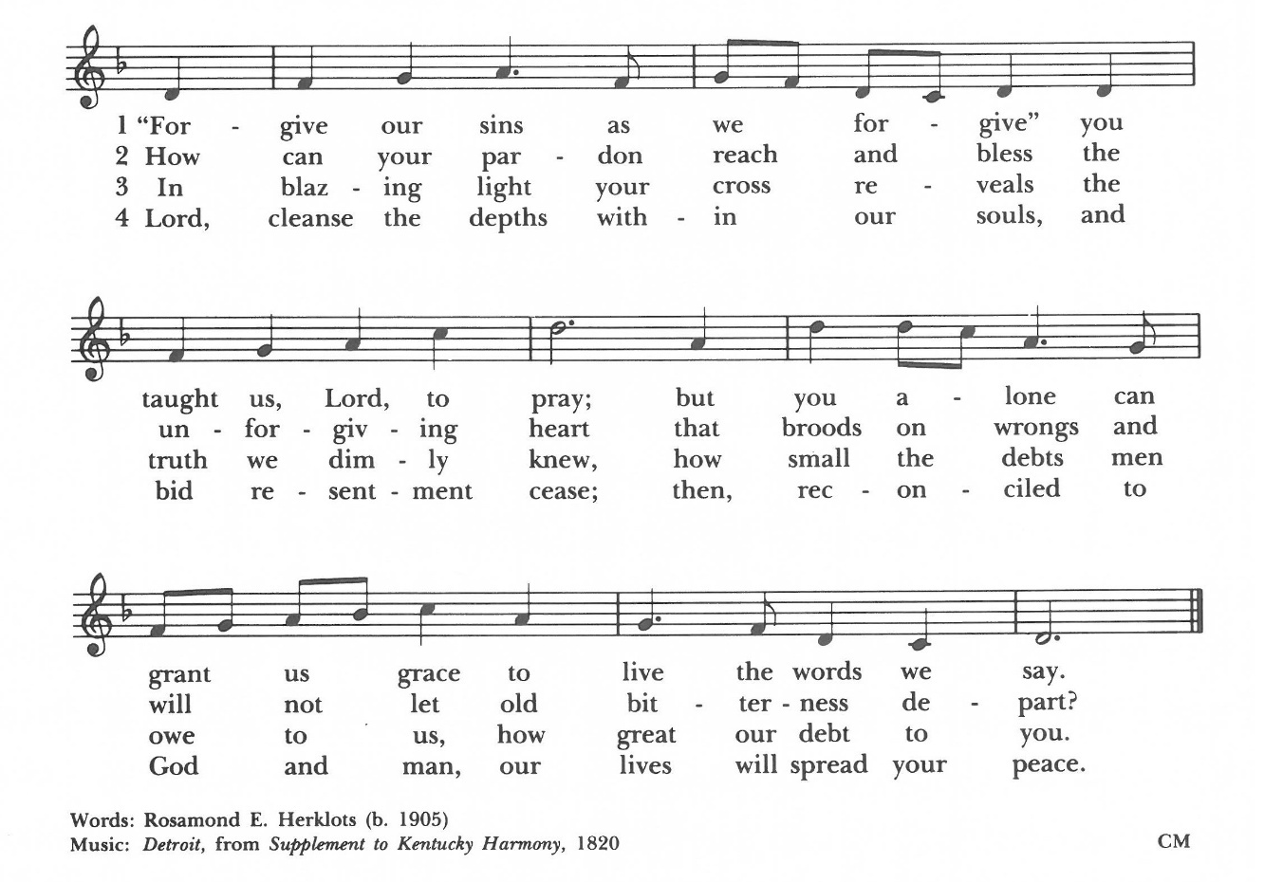

The Prayer after Communion Please stand as you are able.

Celebrant: Let us pray.

Celebrant and People: Loving God,
we give you thanks for restoring us in your image
and nourishing us with spiritual food
in the Sacrament of Christ’s Body and Blood.

Now send us forth a people, forgiven, healed, renewed;
that we may proclaim your love to the world
and continue in the risen life of Christ our Savior. Amen

The Blessing:

Celebrant: The Wisdom of God
the Love of God
and the Grace of God
strengthen you to be Christ’s hand and heart in this world,
in the name of the Holy Trinity. Amen.

Recessional Hymn: Lord make us servants of your peace H-593

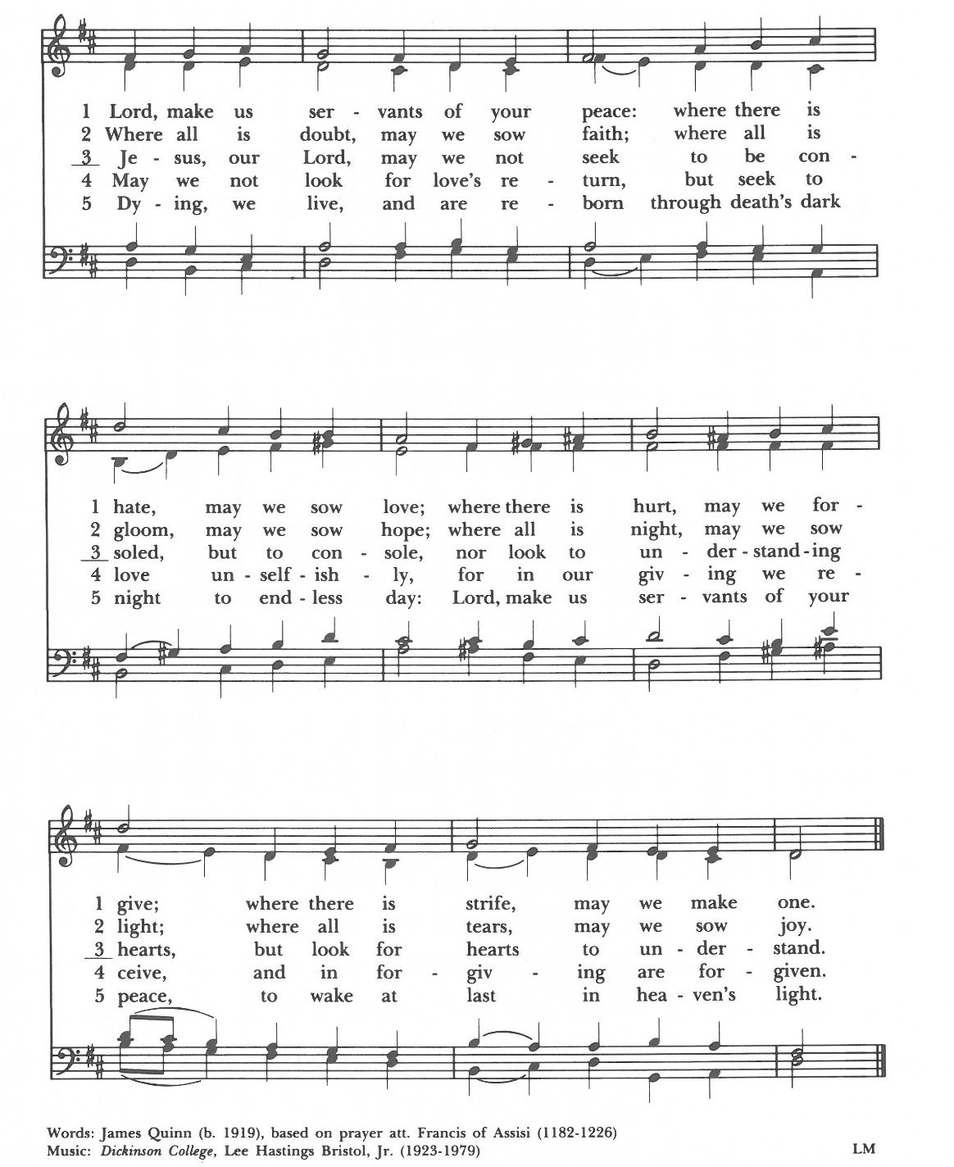
The Dismissal:

Celebrant: Let us go forth in the world, rejoicing in the power of the Spirit.
People: Thanks be to God.

Postlude: Adante for Flute and Piano-W.A. Mozart Christina Roberts, Flute

Please join us in the Parish Hall following the service
For our Annual Meeting and Lunch

Those Serving Today

Celebrant: | Rev. Melanie Slane
Organist: | Joel Hootman
Solo Flutist: | Christina Roberts
Acolytes: | Alex, Javier, Gregory Pfeiler
Lectors: | Nancy Blair and Katie Sparks
Usher: | George Gutermuth
Camera: | Evanthia Owen
Altar Guild: | Mary Siegel, Pat Marcharl, Carol VanOsdol

This Week at Trinity: Feb 2-8, 2026

Monday | 2/2 | 10:00 am | Buildings & Grounds Committee
Wednesday | 2/3 | 7:00 pm | Celtic Compline
Thursday | 2/4 | 1:00 pm | Fellowship Committee

Scripture for February 8th
Old Testament: Isaiah 58:1-9, [9b-12]
Psalm: 112:1-9, [10]
New Testament: 1 Corinthians 2:1-12, [13-16]
Gospel: Matthew 5:13-20

Parish Cycle of Prayer
O God, our times are in your hand: Look with favor, we pray, on your servants Diana Bodenmiller, Sherry Conard, Becky Daffner and Phyllis Donahoe. Grant that they may grow in wisdom and grace and strengthen their trust in your goodness all the days of their lives, through Jesus Christ our Lord. Amen.

Prayer For Those in the Armed Forces
Almighty God, we commend to your gracious care and keeping all the men and women of our armed forces at home and abroad, especially Aaron Griggs, Seth Glenn, and Eean Glenn (grandchildren of Diana Bodenmiller). Defend them day by day with your heavenly grace; strengthen them in their trials and temptations; give them courage to face the perils which beset them; and grant them a sense of your abiding presence wherever they may be, through Jesus Christ our Lord. Amen.



